****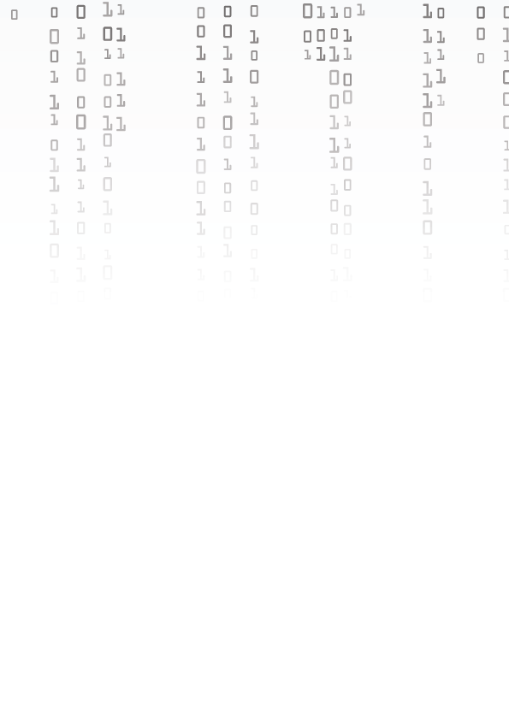

**TEST PLAN**

Table of Contents

Introduction 3

Entry and Exit Criteria 4

Entry Critteria 4

Exit Critteria 4

Objectives 5

Scope of the testing 6

Testing process 7

Results 7

Resources 7

# Table Description automatically generatedIntroduction

**This document provides information about the testing of our game we had to create for a school project related to combat operations.**

# Entry and Exit Criteria

## Entry Criteria

**• We need to make sure everyone has access to the game.  
• QA testing is started after the code development is ready.**

## Exit Criteria

**• Most if not all test cases are successful.  
• There are no critical bugs that can ruin the user experience.**

# Objectives

**The goal is for the game to run smoothly after the code is written and QA checked.**

# Scope of the testing

**• Functions that are related with the functionality of the game.**

**• Functions that are related with the gameplay of the game.**

# Table Description automatically generatedTesting process

## Results

**• Test plan with the test strategy.**

**• A place with every test that was made during the testing process. Which also includes the results.**

## Resources

**• MS Word for making the test plan.**

**• MS Excel for writing test reports and results(QA).**

**• GitHub for reporting issues.**